• Data are the raw facts may not make much meaning to the user.
• Programs are set of instructions that instruct a computer what to do.
• Information is result after data has been processed.

1.2 History of computer and its generation

1.2.1 History of computer
The first counting device was used by the primitive people. They used sticks, stones and bones as counting tools. As human mind and technology improved with time more computing devices were developed. Some of the popular computing devices starting with the first to recent ones are described below:
- Abacus
The history of computer begins with the birth of abacus which is believed to be the first computer. It is said that Chinese invented Abacus around 3,000 BC. At that time abacus was used excessively in Russia, Japan, China and Greece. It was a wooden rack which
has metal rods with beads mounted on them. The upper part is called heaven and the lower part is called earth. In heaven part, each wire/rod has two beads whereas in the earth part, each rod has five beads. Calculations are performed by manipulating the beads up or down with fingers. Abacus is still used in some countries like China, Russia and Japan.
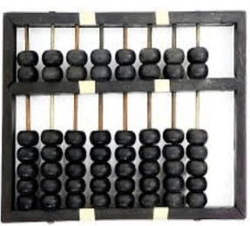
Fig: abacus
- Napier's bones
It was a manually-operated calculating device which was invented by John Napier (1550-1617) of Merchiston. In this calculating tool, he used 9 different ivory strips or bones marked with numbers to multiply and divide. So, the tool became known as "Napier's Bones. It was also the first machine to use the decimal point.
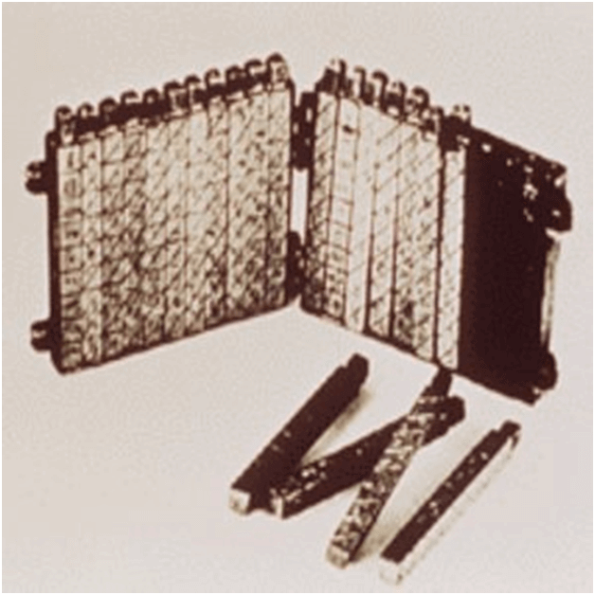
Fig: Napier’s bones
- Slide rule
Slide rule was an analog device invented by William oughtred in 1620. He made the first slide rule by inscribing logarithms on wood. The slide rule is used primarily for multiplication and division also for functions such as roots, logarithms and trigonometry. Before the invention of the pocket or handheld calculator, the slide rule became very popular calculating device. The use of slide rules continued until the electronic calculators were developed. A simple slide rule consists of two movable marked scales in which one scale slips upon the other. The multiplication and division is done by sliding these two rulers.
- Pascaline
Pascaline is also known as Arithmetic Machine or Adding Machine. It was invented between 1642 and 1644 by a French mathematician-philosopher Blaise Pascal. It is believed that it was the first mechanical and automatic calculator.
Pascal invented this machine to help his father, a tax accountant. It could only perform addition and subtraction. It was a wooden box with a series of gears, dials and wheels. The numbers were entered by dialing a series of numbered wheels, where the movement of wheels started at 9 and moved to 0. A series of windows is given on the top of the wheels to read the totals.
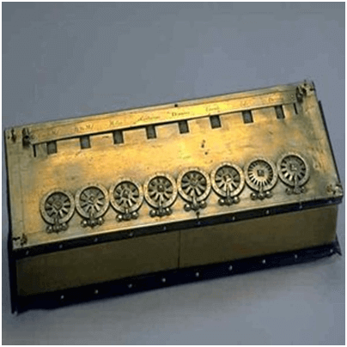

- Stepped Reckoner or Leibnitz wheel
It was developed by a German mathematician-philosopher Gottfried Wilhelm Leibnitz in 1673. He improved Pascal's invention to develop this machine. It was a digital mechanical calculator which was called the stepped reckoner as instead of gears it was made of fluted drums. It was the first calculator that could perform- addition, subtraction, multiplication and division. Even square roots could be calculated by series of stepped additions.
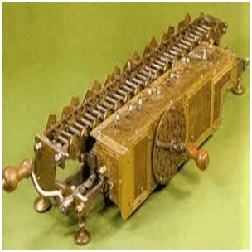
- Jacquard’s Loom
In 1801, a French silk weaver Joseph Marie Jacquard invented automatic weaving machine called Jacquard’s Loom. At that time, this loom revolutionized the weaving industry. The loom was controlled by punched holes, each row of which corresponds to one row of the design. The function of that loom depended upon the absence or presence of holes on the punched cards. This concept gave the idea of binary digit (0, 1). Jacquard’s loom could be considered as the first programmable device.
- Charles Babbage and his engines
The real beginning and the actual thought of modern computer was made by an English mathematician Charles Babbage. He originated the concept of a programmable computer.
- Difference engine
In the early 1820s (1822), it was designed by Charles Babbage who is known as "Father of Modern Computer". It was a mechanical computer which could perform simple calculations. It was a steam driven calculating machine designed to solve tables of numbers like logarithm tables.
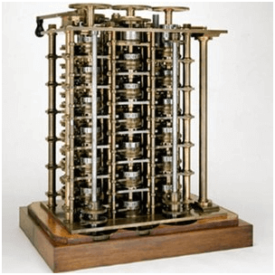
- Analytical Engine
This calculating machine was also developed by Charles Babbage in 1833. This was the first general purpose fully programmable mechanical machine. It was a mechanical computer that used punch-cards as input. It was capable of solving any mathematical problem and storing information as a permanent memory. This engine was based on input, process and output principle since the modern computers are based on the Babbage’s idea and principle.
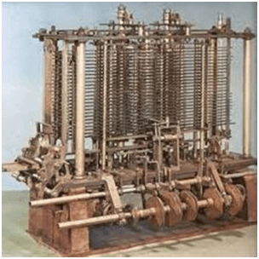
8. Tabulating Machine
It was invented in 1890, by Herman Hollerith, an American statistician. It was a mechanical tabulator based on punch cards. It could tabulate statistics and record or sort data or information. This machine was used in the 1890 U.S. Census. Hollerith also started the Hollerith’s Tabulating Machine Company which later became International Business Machine (IBM) in 1924.
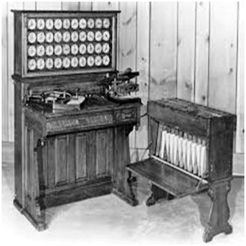
9. Differential Analyzer
It was the first electronic computer introduced in the United States in 1930. It was an analog device invented by Vannevar Bush. This machine has vacuum tubes to switch electrical signals to perform calculations. It could do 25 calculations in few minutes.
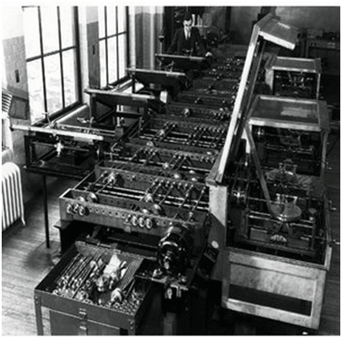
10. Mark I
The next major changes in the history of computer began in 1937 when Howard Aiken planned to develop a machine that could perform calculations involving large numbers. In 1944, Mark I computer was built as a partnership between IBM and Harvard. It was the first programmable digital computer. It has been described as “the beginning of the era of the modern computer”. It uses 18000 vacuum tubes to store data in the memory. The machine weighted 35 tons, incorporated 500 miles of wire, was 8 feet tall and 51 feet long.
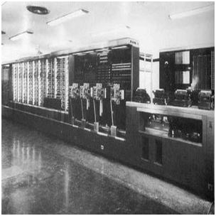
11. Atanasoff berry computer (ABC)
ABC was the first electronic digital computer. This computer was designed by Dr. John Vincent Atanasoff and Clifford Berry in 1942. It used 19000 vacuum tubes as the main memory to store data. ABC was mainly used by military to compute firing and blasting data.

1.2.2 Generations of Computers
(https://medium.com/@technicalgoals2021/generation-of-computer-1st-to-5th-with-pictures-d165869775a6 )
A generation of computers refers to the specific improvements in computer technology with time. In 1946, electronic pathways called circuits were developed to perform the counting. It replaced the gears and other mechanical parts used for counting in previous computing machines.
In each new generation, the circuits became smaller and more advanced than the previous generation circuits. The miniaturization helped increase the speed, memory and power of computers. There are five generations of computers which are described below:
First Generation Computers (1945-1955)
The first generation of the computer (1945-1955) used vacuum tubes for the circuitry and the magnetic drums for the memory and taking up the big rooms. It was very expensive to operate and uses a great amount of electricity and produced a large amount of heat. The first generation of the computer relied on the machine language, the lowest level programming language which was understood by the computers to perform the various functions and operations. It can solve the one problem at a time can’t do the multitasking work. The input was based on the punched cards and the paper tape and the output was displayed on the printouts. Some of the popular first generation computers are;
ENIAC (Electronic Numerical Integrator and Computer)
EDVAC (Electronic Discrete Variable Automatic Computer)
UNIVACI (Universal Automatic Computer)
IBM-701
IBM-650
Advantages of the First Generation of the Computer
- The computer was very fast to calculate.
- The vacuum tube technology made possible the advent of electronic computers.
- Those days this was the only electronic.
Disadvantages of the First Generation of the Computer
- The first generation of computer is not portable.
- It is not reliable devices.
- An air-conditioned is required.
Second Generation Computers (1956-1964)
The second generation (1956-1964) was the era of the transistor computers. These computers used transistors which were cheap, compact and consuming less power; it made transistor computers faster than the first generation computers.
In this generation, magnetic cores were used as the primary memory and magnetic disc and tapes were used as the secondary storage. Assembly language and programming languages like COBOL and FORTRAN, and Batch processing and multiprogramming operating systems were used in these computers.
Some of the popular second generation computers are;
IBM 1620
IBM 7094
CDC 1604
CDC 3600
UNIVAC 1108
Advantages of the Second Generation of the Computer
- More reliable than the first generation.
- Good speed and can calculate the data in the microseconds.
- Also used assembly languages.
- Smaller in the size as compared to the first generation.
- Use less amount of energy.
- Portable
- Accuracy is improved than its predecessor ( 1st generation).
Disadvantages of the Second Generation of the Computer
- Constant maintenance is required to work properly.
- Commercial production was very difficult.
- Still punched cards were used for input.
- The cooling system is required.
- More expensive and non-versatile.
- Used for specific purposes.

Third Generation Computers (1965-1971)
The third generation computers (1965-1971) used integrated circuits (ICs) instead of transistors. A single IC can pack huge number of transistors which increased the power of a computer and reduced the cost. The computers also became more reliable, efficient and smaller in size. These generation computers used remote processing, time-sharing, multi programming as operating system. Also, the high-level programming languages like FORTRON-II TO IV, COBOL, PASCAL PL/1, ALGOL-68 were used in this generation.
Some of the popular third generation computers are;
IBM-360 series
Honeywell-6000 series
PDP (Personal Data Processor)
IBM-370/168
TDC-316
Fourth Generation Computers (1972-2010)
The microprocessor brought in the fourth generation of computers (1972-2010). Thousands of the integrated circuits were built on the single silicon chip. The first generation of computer occupies the entire room but now the fourth generation of computer fit in the palm of the hand. In 1971 Intel 4004 chips were developed which was located to all the components of the computer. IBM introduced its first computer for home users in 1981. The fourth generation of the computer became more powerful and could be linked together to form the networks which led to internet development. In the fourth generation of computer, we saw the development of the GUIs, keyboard, mouse and other hand handled devices.
Some of the popular fourth generation computers are;
Desktop
Laptop
Note Book
Advantages of the Fourth Generation of the Computer
- The air conditioner is not required.
- Totally used for general purposes.
- Small and compact in size.
- Heat generated is negligible which is good.
- Faster than its predecessor.
Fifth Generation Computers (2010 – present)
The fifth generation of the computer (2010- present) is based on artificial intelligence and still in development. There are many applications which are used in this generation like voice recognition which is being used today. The use of superconductors and parallel processing helps to make the AI a reality. The goal or target of this generation is to develop the devices that respond to natural languages.
Advantages of the Fifth Generation of the Computer
- More reliable and faster than its predecessor.
- Easily available in different sizes with unique and different features.
Disadvantages of the Fifth Generation of the Computer
- Disadvantages of the fifth generation of the computer have yet to be agreed upon.

1.3 Importance of computer in 21st century
In this day and age, it has become unimaginable to live without computers. They have come to be very essential in our daily life. Everyone in every age bracket makes use of the computer to fulfill different types of needs. Every sector of the world has gained from the use of a computer; its advantages can never be underestimated. Some of the importance of computer system is listed below:
Fast and Easy Learning
Computers have a big role in the learning process in education. Students can easily comprehend (understand) what they are being taught with the help of the computer, through videos that show what they are being taught and with other resources made available from using the computer. For instance, computer animations and graphics can be used to understand how the earth moves and the phenomenon of the solar and lunar eclipse. Online classes and lectures are made possible with the help of the computer; you can easily get the education without having to be within the four walls of a school.
Increased productivity
Computers help to make workers faster and much more productive. It saves valuable time in the office or business. It makes filing and keeping database and tracking records fast. Account keeping and record keeping is now much easier and less stressful than it used to be in time past. The use of the computer eliminates the abuse of workload while increasing the effectiveness of trade and industry. A computer makes processes very easy in the business sector.
Quick and Cashless Bank Transactions
Online banking is another way that computer helps in banking; you can retrieve all your previous transaction records within a minute, transfer and receive money from your home, school or office with the click of few buttons. The days are gone, that you have to stand on queues just to send or transfer money.
A computer makes banking easy, fast and stress-free. The use of computers also save the banks much money, they can make use of customized software programming that eliminates paper check transfers. You do not have to carry lots of cash around as there are bank terminals in supermarkets, factories, schools, hotels, eateries and many more places. Salaries of employees can easily be paid more safely and faster by just inputting employees’ account numbers. The use of the computer reduces frauds in banking.
Assistance to the Disabled
The computer also helps those who are disabled. Microprocessor based voice system help people with disabilities speaking with terminals that directs the computer to a verbal job, helps the deaf to communicate and the blind to see either with the use of the keyboard or the help of speech synthesizers. The computer makes the disabled to be more active, performing the task that they could not before.
Easy Exchange of Information and communication
The computer acts as a source of getting lots of information and also a source of giving information out. The computer makes it easy to exchange information, news and reports about advance medical development around the world. Communication is made easy by the use of emails; it is a fast means of communication and cost little. Seminars, meetings and conferences can be done between company heads with the use of web video conferencing and can also be broadcasted to all their employees without having to move around.
Data Processing, Organization and Presentation
The computer provides the equipment to help manage in the office environment. It provides a word processing type of electronic method that helps in the production and editing of letters, documents, reports and any other thing that needs to be typed. The computer can be used to send memos, prepare spread presentations and spreadsheets. The computer is important in the storing of patient records, scheduling nurses, doctors and other medical personnel, indexing and purchase of drugs and many other things. All bank data can easily be collected and stored in a computer, and they are also easy to retrieve. Lots of time can be saved when processing data. Books can easily be categorized and catalogued with the help of the computer.
Things such as student registration, class scheduling and test and examination result processing can be carried out fast and efficiently by the computer aiding the school administration.
Diagnose of Diseases and Monitoring
The use of information technology and computer-based equipment has helped doctors to diagnose diseases. It can solve complex problems in the medical field. The computer can be used to oversee body temperature, blood pressure and ECG of a patient, sounding a warning when something goes wrong.
Research
A computer makes researching much easier and less time to consume for professors, students, researchers who research. Research can be done in an efficient and fast way, reducing the stress that usually accompanies it. A researcher does not have to visit the library. The computer provides a better opportunity for researchers to also share their works with others.
Entertainment
Computer is also playing very important role for the entertainment of people. Nowadays computer has become a mean of human entertainment. You can easily store your music in any computer device instead of stocking of CDs; you can download and watch movies without having to buy DVDs. You can play video games with video games consoles or any other device for your entertainment.

Advertising and Online purchase
Computers also make easy for small-scale businesses and companies to advertise their products and services to lots of customers and to be able to understand the demands of customers. A computer helps your products and services available 24/7. Computers can be used to make reservations at restaurants, hotels, hair salons etc. to reduce wait time. You can purchase any product or order any services with the use of the computer from anywhere you are and from anywhere in the world.
That 10 importance of computer we mentioned can be seen by the number of people who make use of it every day. In this time and age, you don’t need to go through long and stressful processes to perform certain activities. The computer is always there to make your work easier for you; you just have to give it a command. There are endless possibilities with computers.

